NPRE598 PRA HW7 Plots of hazard rate for different time T. Jinsheng(Jason) Wang

1. T = 100

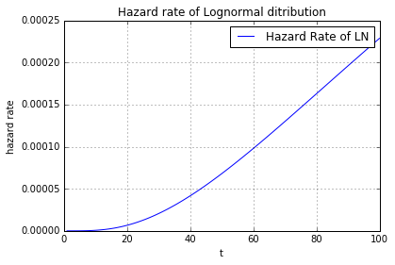

The beginning increasing trend is like part III of bathtub curve.

1. T = 10,000

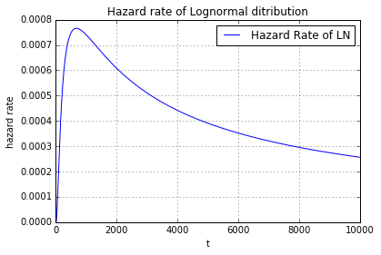

1. T = 100,000

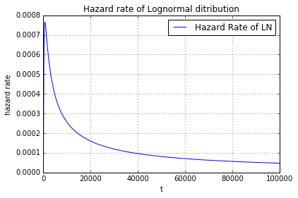

When we increase the time, it can be seen that the overall trend is decreasing, agreeing with the part I of bathtub curve.